**Water Level Monitoring System used in Water Tank Systems**

**Submitted By- Apoorva Rumale(190420116058) & Harsh Thakkar(190420116068)**

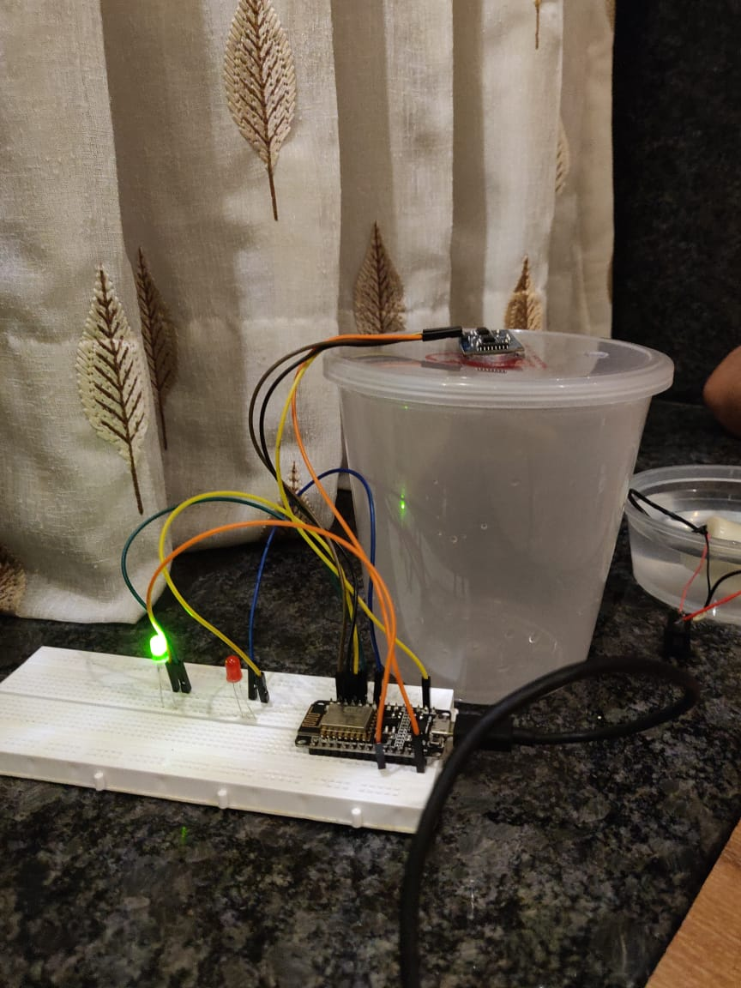

[Water Level Monitoring System]

The Water Level Monitoring System is used to constantly monitor the water level in underground or overhead tanks. It uses sensors which monitors the water level inside the tank and processes data about the water level and the amount of water in it.

* Devices Used:
* Submersible mini water pump
* Ultrasonic sensor :

An ultrasonic sensor is an electronic device that measures the distance of a target object by emitting ultrasonic sound waves, and converts the reflected sound into an electrical signal. Ultrasonic waves travel faster than the speed of audible sound (i.e. the sound that humans can hear). Ultrasonic sensors have two main components: the transmitter (which emits the sound using piezoelectric crystals) and the receiver (which encounters the sound after it has traveled to and from the target).

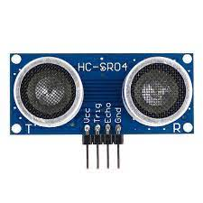

* NodeMCU
* Jumper wires
* 9V Battery
* Red LED
* Green LED
* Switch
* Circuit Photo:

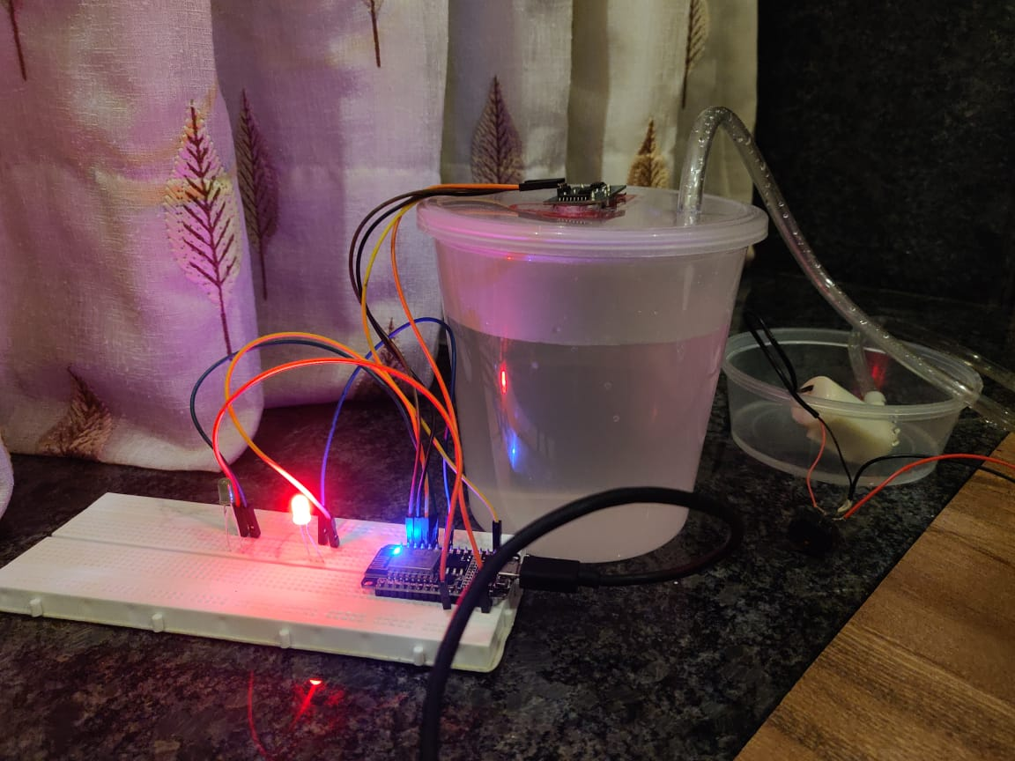

* Working :

The Water Level Monitoring System is our solution as a Home Automation System for water management. It uses Ultrasonic Sensor, NodeMCU, LEDs and a battery operated submersible mini water pump.

The sensor is fitted on the top of the tank in such a way that it can sense the rising water level inside the tank. The pump is connected to the battery and is turned on while the LED blinks green that means water level is below specified level and can be filled. Once the water level reaches the limit the Ultrasonic Sensor senses the water level and LED blinks red. At this point the pump is to be turned off. The limit is set to 5cm below the sensor and it displays water volume in the console.

* Code:

#include "ThingSpeak.h"

#include <ESP8266WiFi.h>

const int trigPin1 = D1;

const int echoPin1 = D2;

#define redled D3

#define grnled D4

unsigned long ch_no = 1887208;//Replace with Thingspeak Channel number

const char * write_api = "SB88QUJJ7PH2UHQZ";//Replace with Thingspeak write API

char auth[] = "mwa0000027854876";

char ssid[] = "OnePlus 8";

char pass[] = "e2xfufxn";

unsigned long startMillis;

unsigned long currentMillis;

const unsigned long period = 10000;

WiFiClient client;

long duration1;

int distance1;

void setup()

{

pinMode(trigPin1, OUTPUT);

pinMode(echoPin1, INPUT);

pinMode(redled, OUTPUT);

pinMode(grnled, OUTPUT);

pinMode(D3, OUTPUT);

pinMode(D4, OUTPUT);

digitalWrite(redled, LOW);

digitalWrite(grnled, LOW);

Serial.begin(9600);

WiFi.begin(ssid, pass);

while (WiFi.status() != WL_CONNECTED)

{

delay(500);

Serial.print(".");

}

Serial.println("WiFi connected");

Serial.println(WiFi.localIP());

ThingSpeak.begin(client);

startMillis = millis(); //initial start time

}

void loop()

{

digitalWrite(trigPin1, LOW);

delayMicroseconds(2);

digitalWrite(trigPin1, HIGH);

delayMicroseconds(10);

digitalWrite(trigPin1, LOW);

duration1 = pulseIn(echoPin1, HIGH);

distance1 = duration1 * 0.034 / 2;

Serial.println(distance1);

if (distance1 <= 2 )

{

digitalWrite(D3, HIGH);

digitalWrite(D4, LOW);

Serial.println("Stop ! water has reached the required level...");

delay(500);

}

else

{

digitalWrite(D4, HIGH);

digitalWrite(D3, LOW);

delay(500);

}

currentMillis = millis();

if (currentMillis - startMillis >= period)

{

ThingSpeak.setField(1, distance1);

ThingSpeak.writeFields(ch_no, write_api);

startMillis = currentMillis;

}

}